**6 Digital trends in the healthcare industry for 2021**

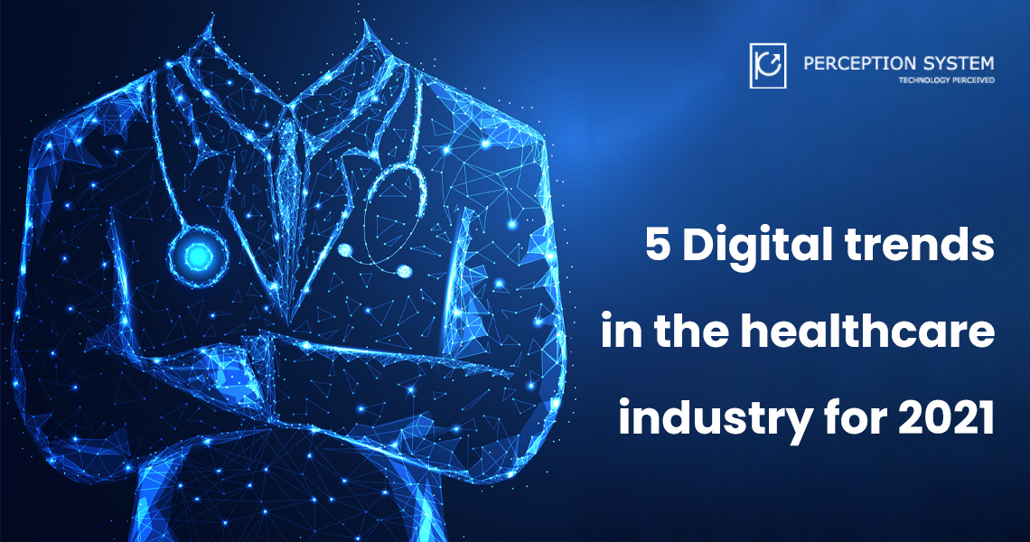

**Keywords: -** healthcare mobile app development, professional healthcare applications, healthcare application development

Technology is reshaping how we live our lives post the coronavirus pandemic. We are standing at a point where a global healthcare crisis could convert into a global health industry revolution with increased funding and higher opportunities from the government, civil society and investors.

The biggest driver for this global change in the healthcare industry is the arrival of Artificial Intelligence (AI), cloud computing, the Internet of Things (IOT), and many other factors of the [fourth industrial revolution](https://www.veriday.com/blog/fourth-industrial-revolution-healthcare/#:~:text=The%20Fourth%20Industrial%20Revolution%20will%20benefit%20all%20sectors%20and%20industries,eventually%20be%20available%20to%20everyone.) which ensure faster, smoother medical advancements which will make world-class healthcare accessible for everyone.

After the coronavirus pandemic, the focus of the world is changing rapidly. With the beginning of the [world’s largest vaccination program](https://www.thehindu.com/news/national/coronavirus-worlds-largest-vaccination-programme-begins-in-india-on-january-16/article33582069.ece) towards modernizing the healthcare industry, the focus has shifted towards developing technologically advanced and user – friendly professional healthcare applications. Biotechnology and smart medicine fuelled by virtual reality will lead the path in healthcare application development for the future.

5 digital trends in the healthcare industry for 2021 are: -

1. **Telehealth**

Due to restricted movement and measures for prevention of contact amongst patients’ physical workplaces and clinics have closed down. Healthcare professionals around the world started using telehealth services for seeing patients remotely except during an emergency. The use of telehealth resources has advanced significantly after the pandemic.

Global telehealth and telemedicine market is expected to grow at a [CAGR of 37.7%](https://www.marketsandmarkets.com/Market-Reports/telehealth-market-201868927.html) during the forecast period and is expected to reach $191.7 billion in revenues in 2025 from approximately $38.7 billion in 2020. Demand for services like appointment management, audio/video communication, live videoconferencing, remote patient monitoring, secure messaging, online prescription management and much more is increasing rapidly.

1. **Artificial Intelligence (AI)**

From thermal screening to pandemic detection and outspread monitoring, artificial intelligence has proven to be the real assistant of the people during this pandemic. It pioneered the revolution by providing early warning systems for identifying pandemics like Covid – 19 and also assisted healthcare policymakers in figuring out a potential local outbreak of the disease.

To most of the people, artificial intelligence is limited to some robots conducting surgeries or robotics used in caregiving and nursing industry but it is a lot more than that. Some other uses of artificial intelligence in healthcare include chatbots, virtual health assistants, precision medicine, workflow optimization, cybersecurity, blockchain and much more.

1. **Internet of Medical Things (IOMT)and Wearable Medical Devices**

The internet of medical things is a combination of several wearable medical devices and mobile applications used to provide treatment to patients by doctors. IOT includes goods and services used digitally over the internet. By combining IOT and healthcare technology, a new branch has been developed known as the Internet of Medical Things (IOMT).

Due to this, healthcare companies have started to make huge investments in developing proactive, wearable technology devices integrated with professional healthcare mobile applications. They could determine the current health status of a high – risk patient and also alert the medical professional in case of a high-risk event.

Research shows that the average revenue of the wearables industry has increased constantly over – time since 2012. In 2012 it was around $25 Billion which has now increased to $65 Billion just in the first half of 2020 after the arrival of the Covid – 19 pandemic.

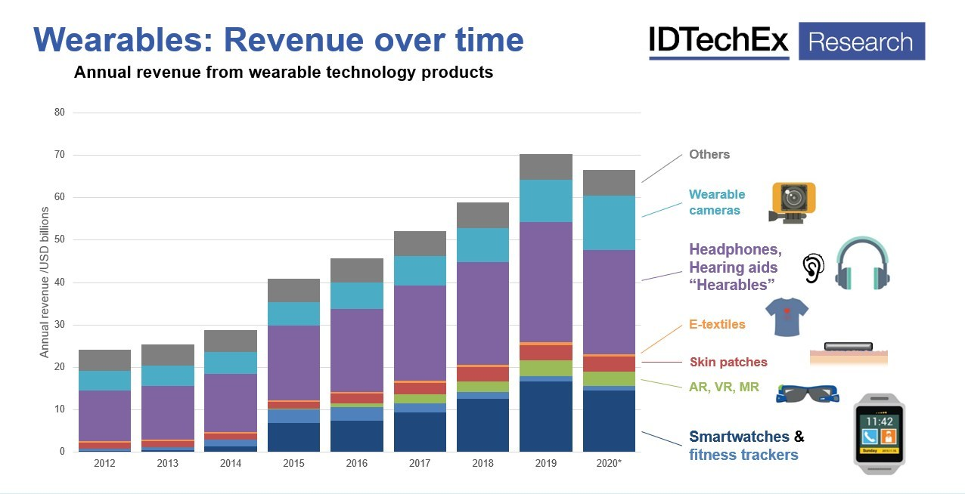

Source: - <https://www.prnewswire.com/news-releases/the-technology-of-covid-19-unprecedented-shifts-in-healthcare-technology-adoption-explored-by-idtechex-301177339.html>

IOMT has set new standards in personalized healthcare and has proven to be extremely efficient in managing both normal and vulnerable patients. Devices keeping the track of your movements and personal health developments are truly a trend to watch out for.

1. **Augmented Reality (AR), Virtual Reality (VR) and Mixed Reality (MR)**

If we would have told you this before a couple of years that your pain could be healed with a video game-like device then you would have believed it to be unrealistic. From enhancing patient experience in the medical clinics to providing medical students with a better outlook to understand the medical world this technology is surely going to be the definitive factor for tomorrow’s medical world.

AR, VR and MR have contributed greatly to improve the experience of doctors as well as patients. It is nowadays used to heal motor deficiencies, dementia, cognitive impairments and other chronic diseases. According to several healthcare professionals, [VR is a safer and effective alternative to drugs](https://healthtechmagazine.net/article/2018/04/new-virtual-reality-pain-management-study-unites-all-aspects-care) in healing chronic diseases.

1. **Mobile health applications**

Healthcare applications on the mobile have been popularized post-pandemic with several e-commerce giants leaping into the medicine home delivery business. Moreover, they have also been used to conduct doctor appointments virtually, and to expand patient care beyond the walls of the clinic.

Every pharmaceutical and healthcare company invests in mobile applications because their numerical value in revenue generation is expected to cross [$60 million](https://www.signitysolutions.com/blog/healthcare-mobile-apps/) by the end of 2020.

Mobile health applications provide easy information to the user about symptoms, track their body developments, enable payment for services, provide medical prescription and other crucial information about diseases, set reminders about medication, measure their blood pressure and heart rate, and much more.

1. **Collaborative Portals**

When it comes to emerging trends an all in one collaborative portal has become a necessity for the upcoming healthcare industry changes for solid patient engagement, project management, process collaboration and supply chain. The collaborative portals are like an umbrella where all – in – one healthcare service can be accessed easily.

Let us have a look at some of them in brief;

**Patient Portal** – Following the launch of Electronic Medical Records (EMR) and Electronic Health Records (EHR) the use of patient portals is gaining popularity around the world. They are a medium which gives patients more control over their treatments, enable them to check laboratory results, request prescription, update information on insurance, manage unpaid balances and much more.

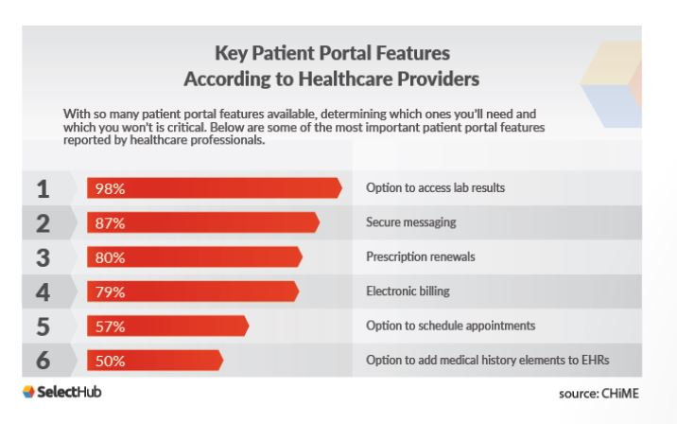

Source: - <https://www.selecthub.com/medical-software/what-is-patient-portal-how-help-medical-practices/>

**Institutional Process Management and Workflow Systems –** Institutional Process Management is something which healthcare professionals around the world have ignored. The time has arrived that we start adopting this technology to prevent any further future digital management issues.

The need to work remotely and collaborate globally has risen and we need proper internal management systems in our healthcare infrastructure for better internal communication in the healthcare systems, dealing with suppliers of surgical equipment, managing billing for vendors and creating new medical partnerships alongwith managing the existing ones.

**Document Management and Project Management Systems –** Maintaining massive number of medical records and keeping records of medical history for patients is something which doctors are required to do. This continues not for some couple of months but for some years. Doctors are required to maintain patient details for at least 7 years after the last visit of the patient which is quite challenging in itself.

Moreover, the whole process requires keeping and managing high paper records which is both challenging and time – consuming. To provide solutions to this problem technological [document management systems](https://www.softwaresuggest.com/blog/role-of-document-management-system-in-the-healthcare-industry/) come to the rescue for doctors which saves cost, have faster document processing time, increase productivity, eliminates human error, helps in maintain regulatory compliances, and leads to reduction in materials and storage needs.

**Supply Chain Management –** [Digital supply networks](https://home.kpmg/xx/en/home/industries/healthcare/covid-19-and-healthcare/ten-ways-health-systems-are-reacting-and-becoming-resilient.html) have gained huge prominence post – pandemic, with integration of artificial intelligence into the global healthcare supply chain several things have changed on this front.

In the health industry post pandemic, healthcare brands and pharmaceutical companies could accelerate their supply chain network by going digital. This could promote online collaborative purchasing and selling, banishment of medicines, easing the supply of Covid – 19 vaccines, health tools and instruments, etc.

The key element to all these changes shall be proper digital healthcare infrastructure, software’s and mobile friendly which support all the stakeholders in the healthcare industry.

**Some final words…**

In these changing times, it is extremely important to keep in pace with the recent developments in the digital healthcare sector. This article aimed to update you with emerging upcoming digital trends in the healthcare industry for 2021.

Therefore, you need someone who looks after the digital needs of your business in these changing healthcare domains. To keep in touch with them it is strongly advisable to opt-in for a [custom healthcare software development](https://www.perceptionsystem.com/healthcare-pharmacy-industries-it-solutions.html) organization which keeps in mind your needs and designs solutions according to them.